Public, Protected and Private Inheritance in C++ Programming

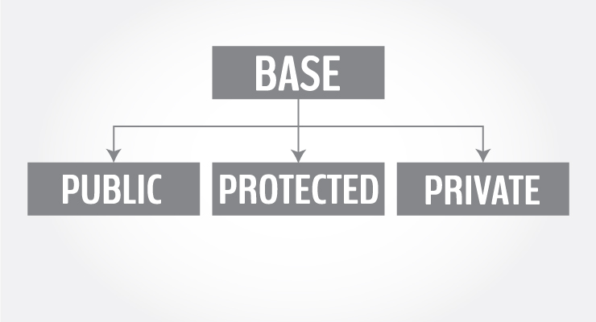

You can declare a derived [class](https://www.programiz.com/cpp-programming/object-class) from a base class with different access control, i.e., public [inheritance](https://www.programiz.com/cpp-programming/inheritance), protected inheritance or private inheritance.

#include <iostream>

using namespace std;

class base

{

.... ... ....

};

class derived : access_specifier base

{

.... ... ....

};

**Note:** Either public, protected or private keyword is used in place of access_specifierterm used in the above code.

## Example of public, protected and private inheritance in C++

class base

{

public:

int x;

protected:

int y;

private:

int z;

};

class publicDerived: public base

{

// x is public

// y is protected

// z is not accessible from publicDerived

};

class protectedDerived: protected base

{

// x is protected

// y is protected

// z is not accessible from protectedDerived

};

class privateDerived: private base

{

// x is private

// y is private

// z is not accessible from privateDerived

}

In the above example, we observe the following things:

* base has three member variables: x, y and z which are public, protected and private member respectively.
* publicDerived inherits variables x and y as public and protected. z is not inherited as it is a private member variable of base.
* protectedDerived inherits variables x and y. Both variables become protected. z is not inherited  
  If we derive a class derivedFromProtectedDerived from protectedDerived, variables x and y are also inherited to the derived class.
* privateDerived inherits variables x and y. Both variables become private. z is not inherited  
  If we derive a class derivedFromPrivateDerived from privateDerived, variables x and y are not inherited because they are private variables of privateDerived.

### Accessibility in Public Inheritance

| Accessibility | private variables | protected variables | public variables |
| --- | --- | --- | --- |
| Accessible from own class? | yes | yes | yes |
| Accessible from derived class? | no | yes | yes |
| Accessible from 2nd derived class? | no | yes | yes |

### Accessibility in Protected Inheritance

| Accessibility | private variables | protected variables | public variables |
| --- | --- | --- | --- |
| Accessible from own class? | yes | yes | yes |
| Accessible from derived class? | no | yes | yes (inherited as protected variables) |
| Accessible from 2nd derived class? | no | yes | yes |

### Accessibility in Private Inheritance

| Accessibility | private variables | protected variables | public variables |
| --- | --- | --- | --- |
| Accessible from own class? | yes | yes | yes |
| Accessible from derived class? | no | yes (inherited as private variables) | yes (inherited as private variables) |
| Accessible from 2nd derived class? | no | no | no |